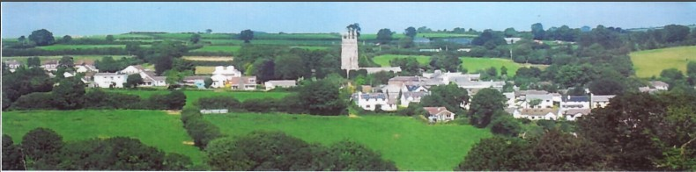

2nd June 2025

Dear Councillor,

You are summoned to attend a meeting of North Hill Parish Council on Monday 2nd June 2025 at 7.30pm in the Village Hall.

Please find attached the agenda for our meeting. We ask that if any member of the public has issues, they would like to raise that they contact the clerk prior to the meeting so that we can best manage them.

Please remember that the time allotted for Matters of Community Concern is not a forum to discuss what has taken place during this meeting and that any matter raised here would likely be added to the NEXT meeting agenda for discussion.

Yours faithfully,

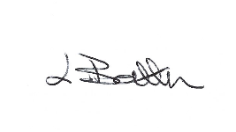

Lena Batten, Clerk to the Council

Members of the public are welcome to attend the meeting. However, we would like those attending to register prior to the meeting by emailing the Parish Clerk. Email: clerk@[northhillparish.org.uk](mailto:northhillparishcouncil@btinternet.com)

**AGENDA**

1. TO RECEIVE APOLOGIES:
2. CODE OF CONDUCT : a) TO RECEIVE DECLARATIONS b) TO GRANT DISPENSATIONS:

3. PUBLIC COMMENTS ON ITEMS ON THE AGENDA ONLY:

4. TO RECEIVE AND APPROVE THE MINUTES OF THE 15th MAY 2025 FULL COUNCIL MEETING:

5. ANY MATTERS ARISING FROM PAST MINUTES NOT ON THE CURRENT AGENDA:

6. TO CONSIDER PLANNING APPLICATIONS RECEIVED FROM CORNWALL COUNCIL BY DATE OF THIS MEETING:

7. ANY APPLICATIONS RECEIVED BEFORE THE DATE OF THIS MEETING: None.

8. TO REVIEW CORRESPONDENCE AND TO AGREED RESPONSES REQUIRED:

8.1 To resolve / confirm Cllr H. Budge as representative for Coads Green Primary School.

8.2 To consider / resolve the quote received from Kompan for the replacement of the steps at the plan

area at a cost of £2022.55. The handyman has confirmed he will prioritise the steps this month.

8.3 To consider / resolve whether to replace the sign at the play area entrance as it is spelt wrong.

8.4 To accept response from Parnalls Solicitors regarding the car park at the village hall and consider

next steps.

8.5 To discuss / resolve the purchase / repair of the dog poo bin between Trebartha and Congdon’s Shop

as the lid is broken.

8.6 To share that St Torney’s Church has a cleaning day on Wednesday 18th June at 10:30 and

volunteers are needed as the church has been shortlisted for the 2025 Cornish Buildings Award.

8.7 To consider / resolve whether to ask for funding for double yellow lines opposite the hall entrance

from the community network panel for Highways improvements.

8.8 To consider / resolve a request for more extensive traffic calming measures outside Coads Green School.

8.9 To confirm three Councillors are still required to sign disclosure of Pecuniary Interests.

9. TO REVIEW DETAILS FOR NORTH HILL PARISH COUNCIL CEMETERY:

A meeting has been arranged for the 16th June 2025 at 7.30pm, an agenda will be sent in advance. Matters discussed will be listed on the July agenda.

10. APPROVAL OF THE LIST OF PAYMENTS / RECEIPTS FOR MAY 2025 & TO RECEIVE 28th MAY 2025 BANK STATEMENT:

10.1 AUTHORISATION OF EXPENSES INCLUDING SALARY:

i) £18.00 (PAYE G. Pollard payroll May, dd)

ii) £673.60 (Lena Batten, May net Salary)

iii) £85.60 (Lena Batten, Tax)

iv) £102.66 (HMRC National Insurance April/May)

v) £43.64 (room rent)

vi) £52.00 (ICO annual registration fee)

10.2 RECEIPTS:

i) None.

10..3 To receive bank statement:

Bank Statement as of 27th May 2025 £17,926.93.

11. TO REVIEW MONTHLY BUDGET RECONCILIATIONS:

11.1 Budget Sheet Attached.

12. TO REVIEW MONTHLY RAG: (Red, Amber, Green)

12.1 RAG Sheet attached.

13. REPORT FROM CORNWALL COUNCIL WARD MEMBER COUNCILLOR PARSONS:

14. ITEMS FOR INCLUSION AT THE NEXT MEETING:

15. DATE & TIME OF NEXT MEETING:

16. CLOSE OF BUSINESS: